Phase 1: Initial Data Exploration Report
Project: Detection of AI-Generated Arabic Text
Comprehensive analysis of "KFUPM-JRCAI/arabic-generated-abstracts" dataset.
--------------------------------------------------

1. Overview of Dataset Splits

Row Counts Summary
Dataset Split | Number of Rows
by_polishing | 2851
from_title | 2963
from_title_and_content | 2574
Total | 8388

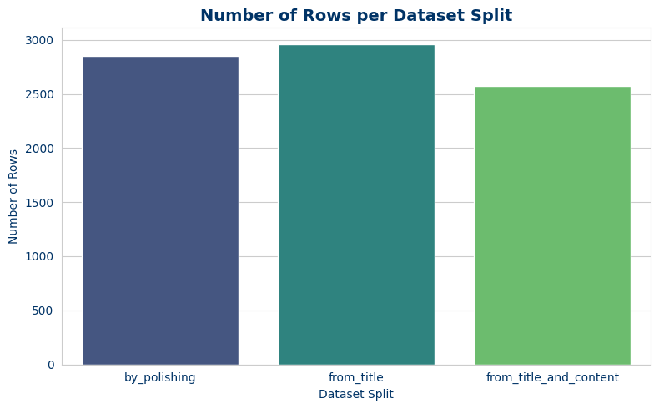

Analysis of Split: by_polishing

Dataset Structure
Column Name | Data Type
original_abstract | Value('string')
allam_generated_abstract | Value('string')
jais_generated_abstract | Value('string')
llama_generated_abstract | Value('string')
openai_generated_abstract | Value('string')

Target Variable Distribution
Class | Count | Percentage
Human-written | 2851 | 20.0%
AI-generated | 11404 | 80.0%
Total | 14255 | 100.0%

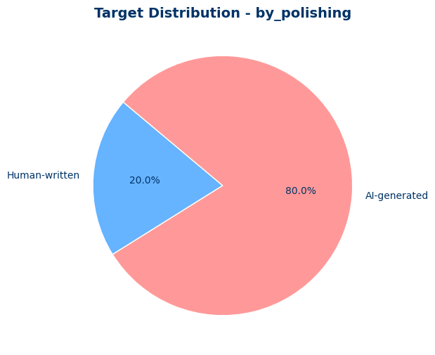

C. Data Quality Assessment

C.1 Missing Values Analysis
Column | Missing Values
original_abstract | 0
allam_generated_abstract | 0
jais_generated_abstract | 0
llama_generated_abstract | 0
openai_generated_abstract | 0
Total | 0

C.2 Duplicates Analysis
Column | Duplicate Count
original_abstract | 0
allam_generated_abstract | 0
jais_generated_abstract | 0
llama_generated_abstract | 0
openai_generated_abstract | 0
Total | 0

C.3 Inconsistencies Analysis
Column | Empty Strings
original_abstract | 0
allam_generated_abstract | 0
jais_generated_abstract | 0
llama_generated_abstract | 0
openai_generated_abstract | 0
Total | 0

D. Statistical Summary of Text Lengths

Descriptive Statistics - by_polishing
Text Type | Average Length | Min Length | Max Length
Human-Written | 119.21 | 75 | 291
AI-Generated | 110.0 | 30 | 265
Total (Combined) | 111.84 | 30 | 291

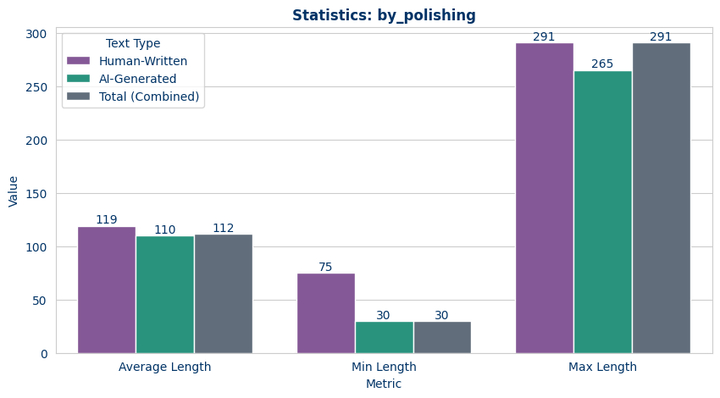

E. Detailed Distribution Analysis (Histograms)

1. Human-Written Text (by_polishing)
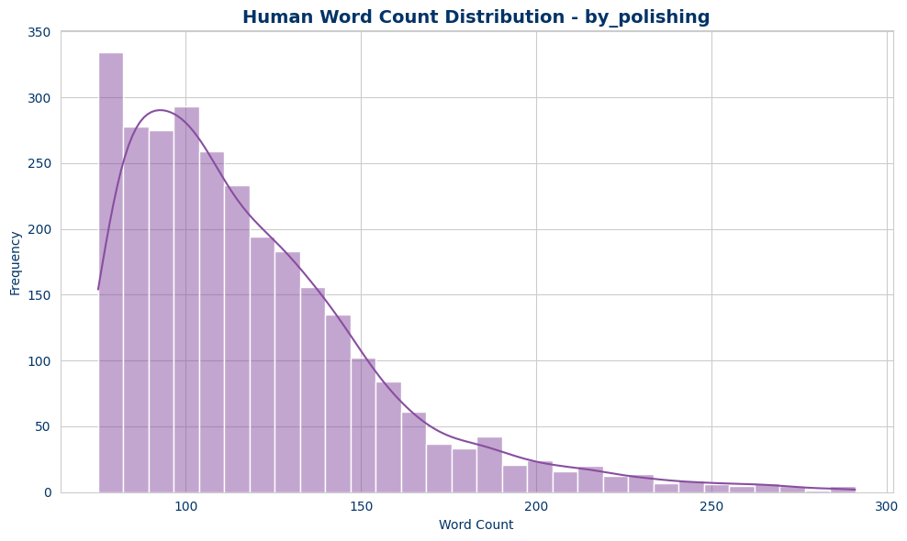

2. AI-Generated Text (by_polishing)
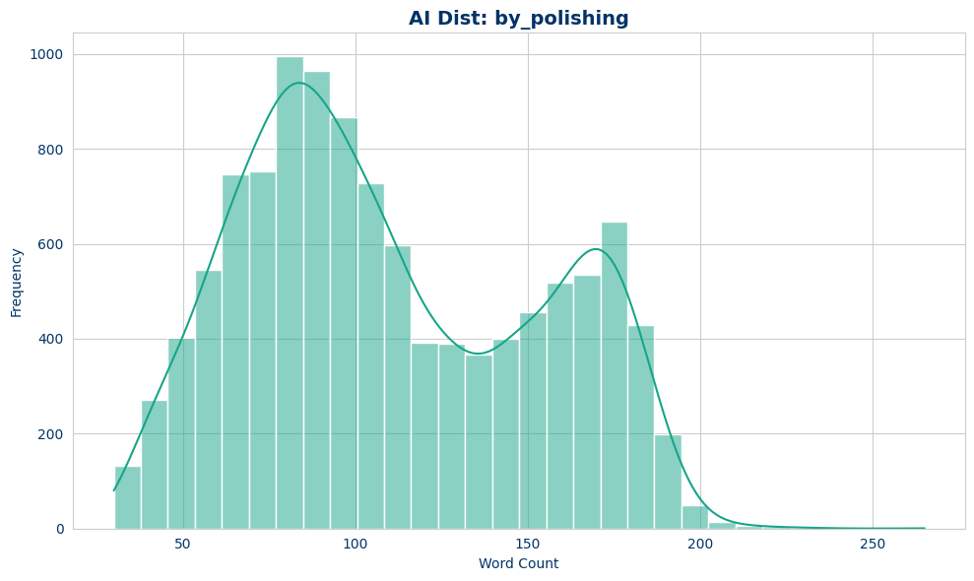

Analysis of Split: from_title

Dataset Structure
Column Name | Data Type
original_abstract | Value('string')
allam_generated_abstract | Value('string')
jais_generated_abstract | Value('string')
llama_generated_abstract | Value('string')
openai_generated_abstract | Value('string')

Target Variable Distribution
Class | Count | Percentage
Human-written | 2963 | 20.0%
AI-generated | 11852 | 80.0%
Total | 14815 | 100.0%

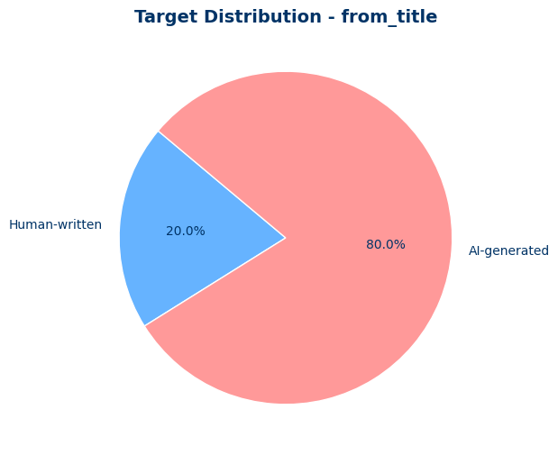

C. Data Quality Assessment

C.1 Missing Values Analysis
Column | Missing Values
original_abstract | 0
allam_generated_abstract | 0
jais_generated_abstract | 0
llama_generated_abstract | 0
openai_generated_abstract | 0
Total | 0

C.2 Duplicates Analysis
Column | Duplicate Count
original_abstract | 0
allam_generated_abstract | 0
jais_generated_abstract | 0
llama_generated_abstract | 0
openai_generated_abstract | 0
Total | 0

C.3 Inconsistencies Analysis
Column | Empty Strings
original_abstract | 0
allam_generated_abstract | 0
jais_generated_abstract | 0
llama_generated_abstract | 0
openai_generated_abstract | 0
Total | 0

D. Statistical Summary of Text Lengths

Descriptive Statistics - from_title
Text Type | Average Length | Min Length | Max Length
Human-Written | 119.13 | 75 | 294
AI-Generated | 90.68 | 30 | 272
Total (Combined) | 96.37 | 30 | 294

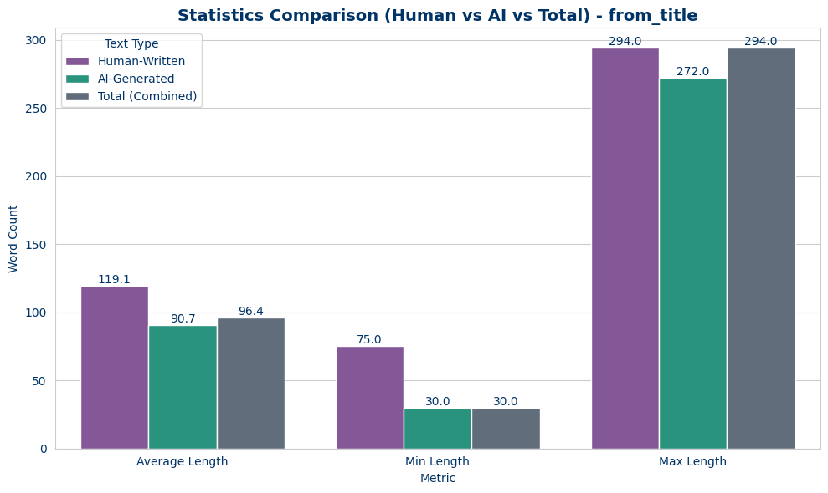

E. Detailed Distribution Analysis (Histograms)

1. Human-Written Text (from_title)
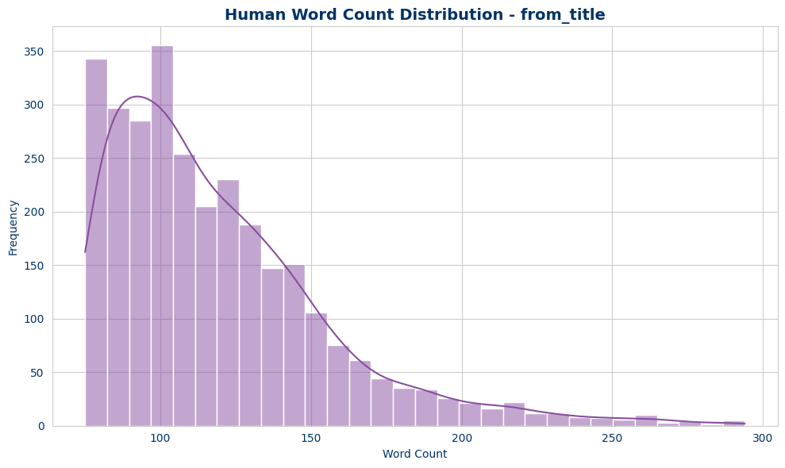

2. AI-Generated Text (from_title)
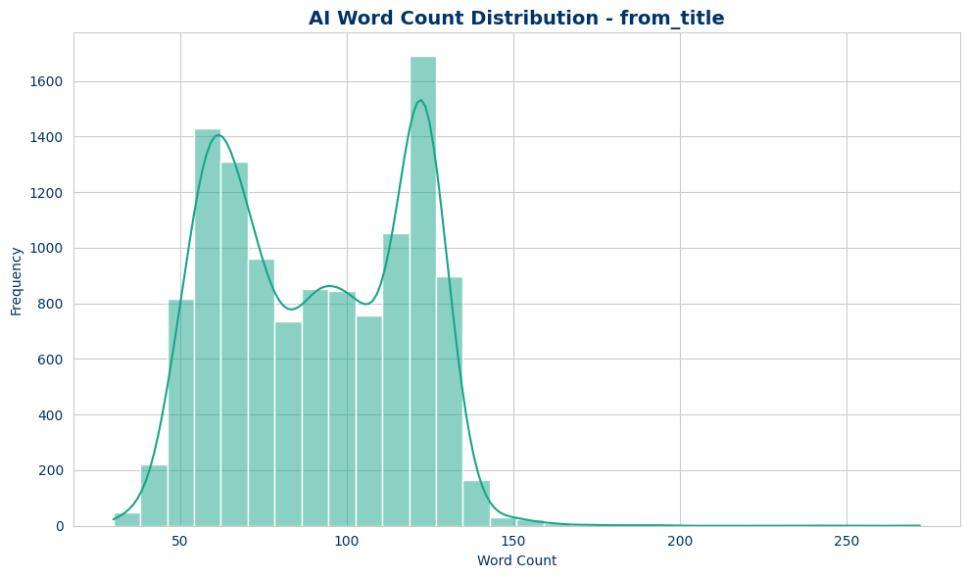

Analysis of Split: from_title_and_content

Dataset Structure
Column Name | Data Type
original_abstract | Value('string')
allam_generated_abstract | Value('string')
jais_generated_abstract | Value('string')
llama_generated_abstract | Value('string')
openai_generated_abstract | Value('string')

Target Variable Distribution
Class | Count | Percentage
Human-written | 2574 | 20.0%
AI-generated | 10296 | 80.0%
Total | 12870 | 100.0%

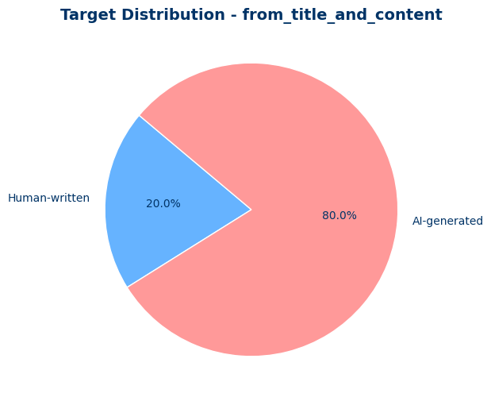

C. Data Quality Assessment

C.1 Missing Values Analysis
Column | Missing Values
original_abstract | 0
allam_generated_abstract | 0
jais_generated_abstract | 0
llama_generated_abstract | 0
openai_generated_abstract | 0
Total | 0

C.2 Duplicates Analysis
Column | Duplicate Count
original_abstract | 0
allam_generated_abstract | 0
jais_generated_abstract | 3
llama_generated_abstract | 0
openai_generated_abstract | 0
Total | 3

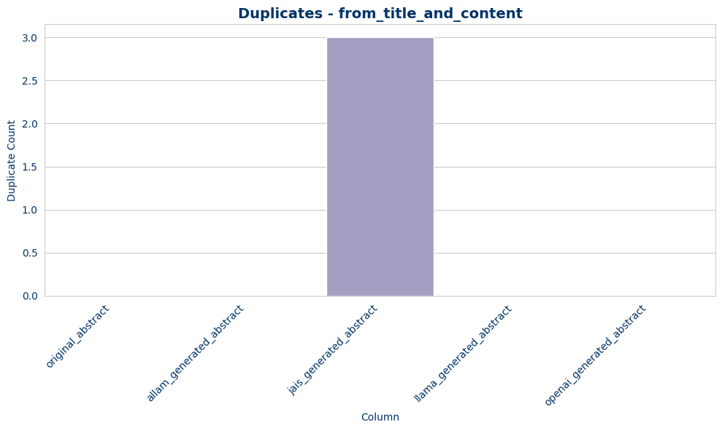

C.3 Inconsistencies Analysis
Column | Empty Strings
original_abstract | 0
allam_generated_abstract | 0
jais_generated_abstract | 0
llama_generated_abstract | 0
openai_generated_abstract | 0
Total | 0

D. Statistical Summary of Text Lengths

Descriptive Statistics - from_title_and_content
Text Type | Average Length | Min Length | Max Length
Human-Written | 119.16 | 75 | 294
AI-Generated | 104.52 | 30 | 372
Total (Combined) | 107.45 | 30 | 372

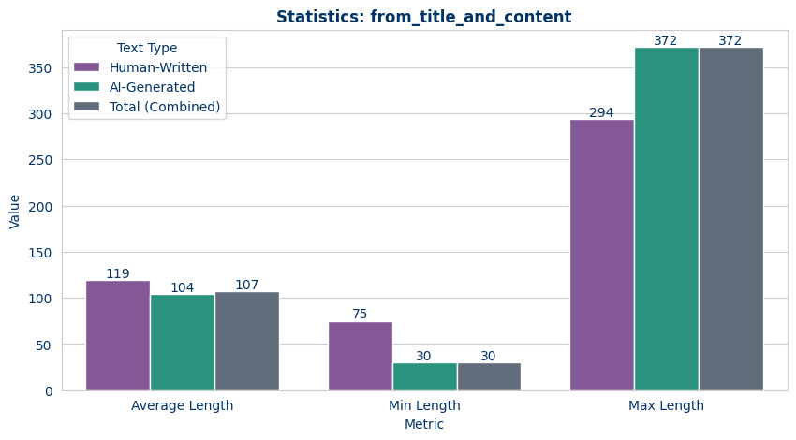

E. Detailed Distribution Analysis (Histograms)

1. Human-Written Text (from_title_and_content)
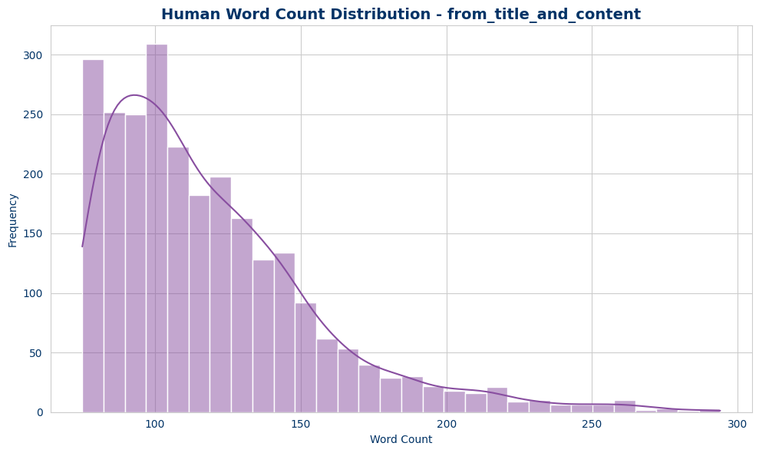

2. AI-Generated Text (from_title_and_content)
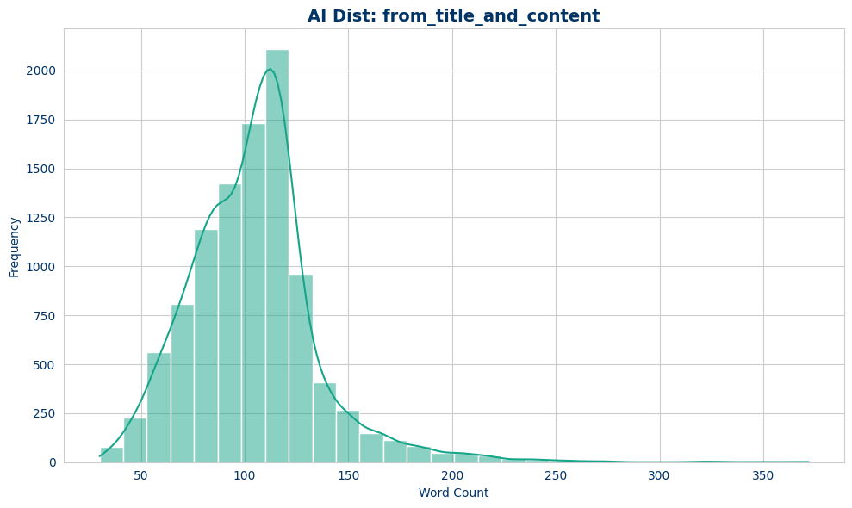

Phase 2: Aggregate Analysis (All Splits Combined)

A. Aggregate Statistical Summary

Descriptive Statistics - All Splits Combined
Text Type | Average Length | Min Length | Max Length
Human-Written | 119.16 | 75 | 294
AI-Generated | 101.49 | 30 | 372
Total (Combined) | 105.03 | 30 | 372

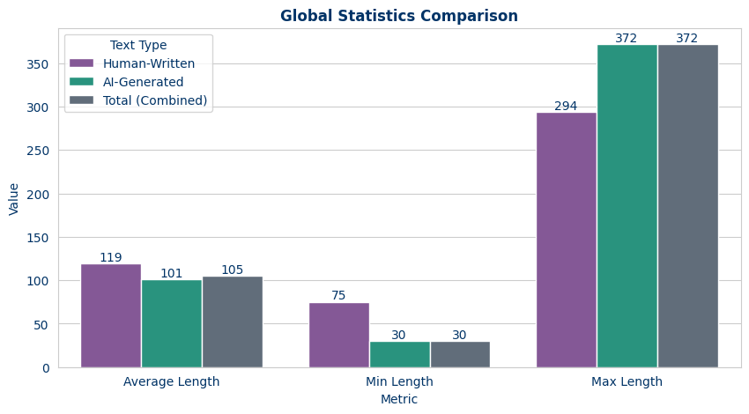

B. Aggregate Distribution Analysis

1. Global Human-Written Text
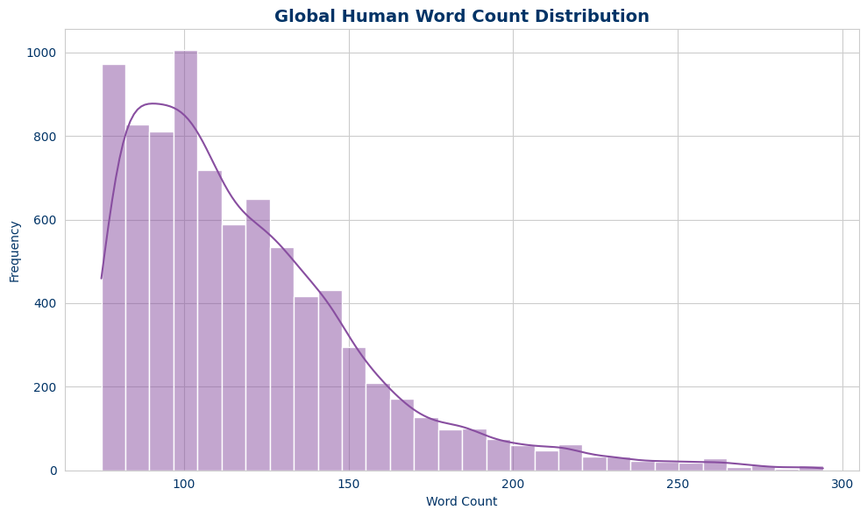

2. Global AI-Generated Text
